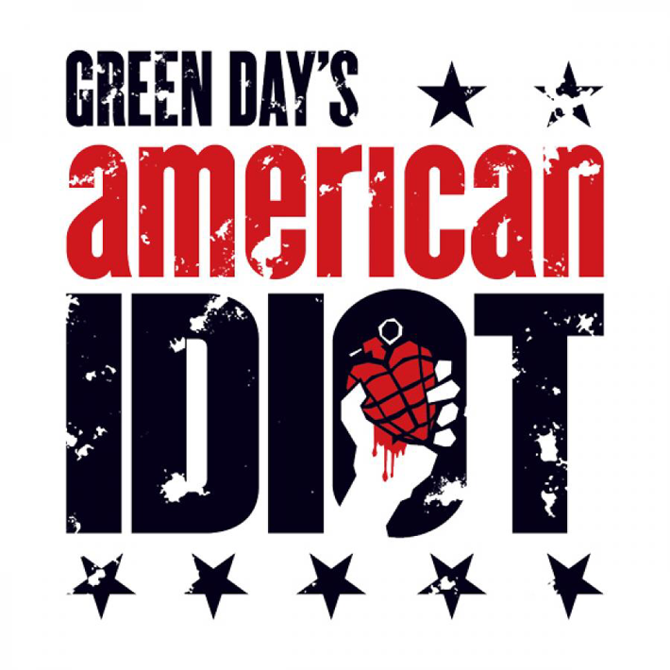
Audition Announcement

The Toledo Repertoire Theatre announce auditions for

“Green Day’s American Idiot”
Music by Green Day
Lyrics by Billie Joe Armstrong
Book by Billie Joe Armstrong and Michael Mayer

Directed by Julie Zatko
Assistant Directed by Hannah Demski
Music Direction by Amy Johns
Choreography by Dom Glover

The two-time Tony Award-winning hit musical “Green Day’s American Idiot”, based on the Grammy Award-winning multi-platinum album, boldly takes the American musical where it’s never gone before. Johnny, Tunny, and Will struggle to find meaning in a post-9/11 world. When the three disgruntled men flee the constraints of their hometown for the thrills of city life, their paths are quickly estranged. An energy-fueled rock opera, “American Idiot”, features little dialogue and instead relies on the lyrics from Green Day’s groundbreaking album to execute the storyline.

AUDITIONS:
Monday, April 15th from 7pm-9pm
Tuesday, April 16th from 7pm-9pm
Wednesday, April 17th from 7pm-9pm
CALLBACKS:
Monday, April 22nd from 7pm-9pm

Auditions will be held on stage at the Toledo Repertoire Theater 16 Tenth St. Toledo OH 43604

Auditions are open to those 16-20 years of age, and will include singing 16-32 bars of a punk/rock song. Those that play an instrument (specifically guitar), are invited to play and/or accompany their song. It is punk rock music, so we are looking for any vocal pyrotechnics you may have (chanting, shouts, screaming, etc.) If you are called back, you will be asked to learn a specific song from the show (sheet music will be provided).

To sign up for an audition slot, please call The Toledo Repertoire Theatre at (419) 243-9277.

Warning: “Green Day’s American Idiot” contains mature and explicit material including strong language, and deals with such topics as drug use, sexuality, and violence. We ask that the parental waiver provided be filled out completely, and turned in at the time of your audition. Due to the mature nature of the show, a mandatory meeting will also be held for the parent/guardian of each cast member.

Show dates are: July 11, 12, 13, & 14, 2019

Questions? Please contact the Toledo Repertoire at (419)243-9277, or visit www.toledorep.org
Concerns? Please contact Director Julie Zatko (567) 277-0347 or jzatko@icloud.com

